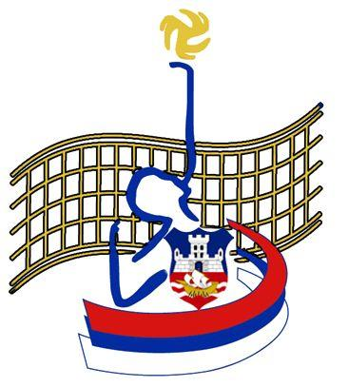 | КЛУБ СЕДЕЋЕ ОДБОЈКЕ ``СМЕЧ`` Београд  SITTING VOLLEYBALL CLUB ’’SPIKE’’ Belgrade

Dear sport friends,

The Sitting volleyball club “SPIKE“ - Belgrade, Serbia, invites Your club team to participate in

7 th International Sitting volleyball Tournament

„BELGRADE TROPHEY 2015“

Date: 30th May 2015 – 31st May 2015
Place: Belgrade,
Sports hall: Sports Centre, Municipality New Belgrade, Belgrade.

Food and accommodation (in the period from 29th May 2015 – 31st May 2015) in the „Dom“ Hostel (http://translate.google.com/translate?u=http://www.portal-srbija.com/turizam/hosteli/hostel-dom&sl=sr&tl=en ), are GRATIS

Costs: all costs for food and accommodation in the period from Friday, 29th May 2015 (lunch) to Sunday, 31st May 2015 (lunch) will be paid by the Organizer.

Note:
Maximum number of the participating team members is 10. In case your team will consist of more than 10 members, the Organiser will not cover food and accommodation costs for these additional members of your delegation. These costs are to be covered by participating teams, as well as all accommodation costs in case of longer staying in our city.

The beginning of the tournament is at 12:00 (noon), 30 th May 2015

Tournament ends on 31 st May 2015, at 2 PM

Please reply to us as follows:

Name: Maksimović Vilimam
Address: 56 Pere Velimirovića street/ 1
City: 11090 Belgrade
Mobile: +381(0)60 686 2310
e-mail: office@ksosmec.org.rs
www.ksosmec.org.rs

Deadline for submitting the registration form is 15th May 2015.

Best regards,

Vilijam Maksimović,
Club chariman

REGISTRATION FORM

(Club) Name | :
 | : | ____________________________________
Address | : | ____________________________________________________________________________________________________________
Phone | : | ____________________________________
Fax | : | ____________________________________
E-Mail | :

Date of arrival | : | ___________________
Time of arrival (approx.) | : | ___________________
Date of departure | : | ___________________

Number of persons |  |  |  |  | : | _________
Wheelchair users |  |  | : | __________
Remarks | :

